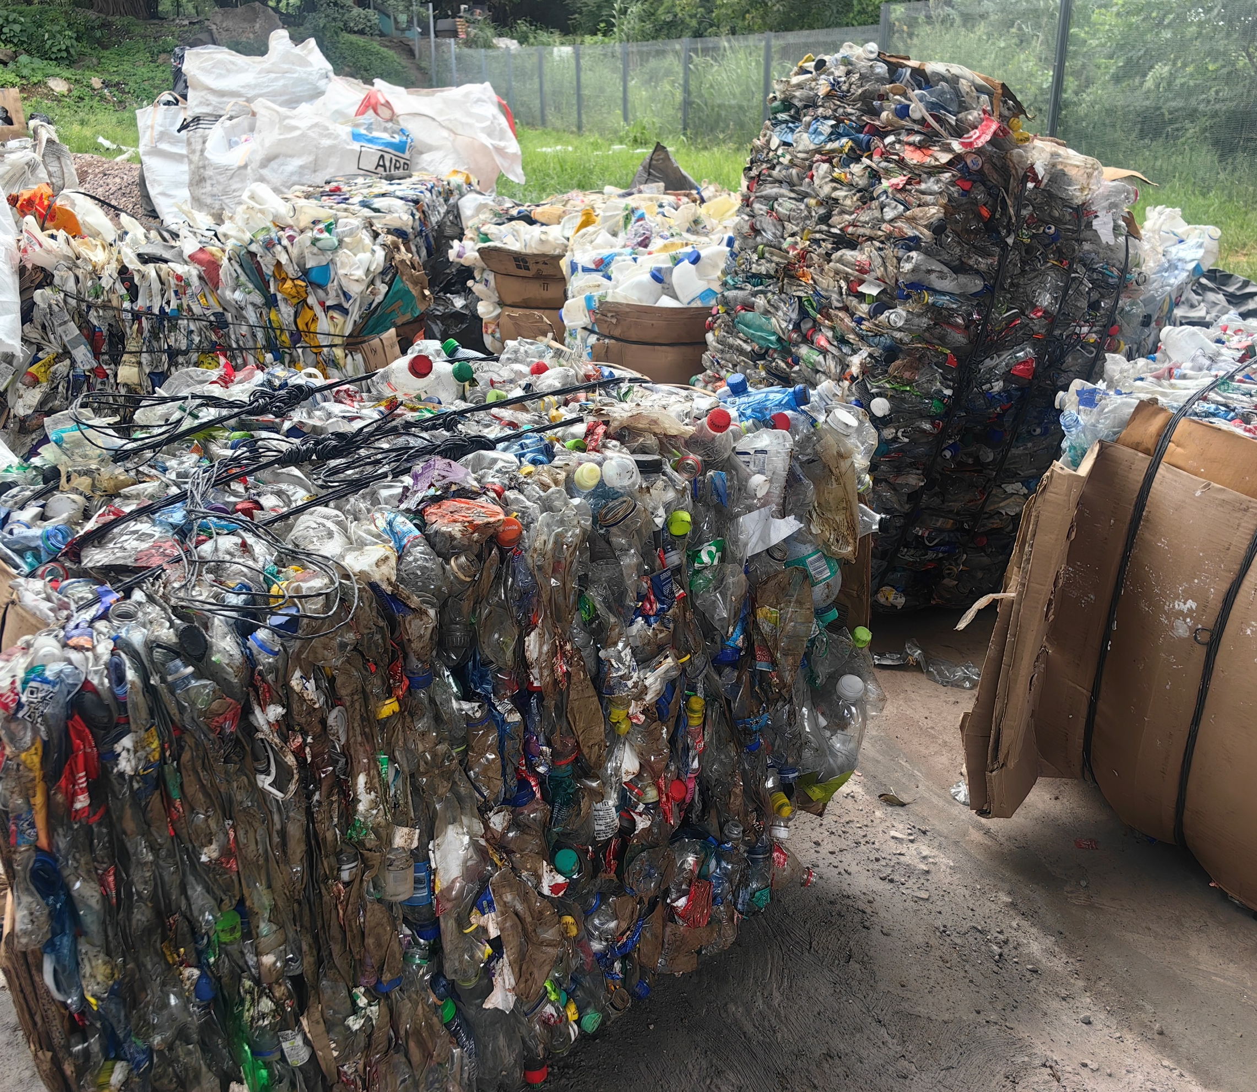
FIRE PLAN-MAVAVELA PROJECTS
CONNAUGHT BRIDGE
Mondli Mbonambi | 7/11/25 | V0.1

Document Control
Always include a document control sheet and update with versions
Item | Description
Document ID | Fire Plan
Document Owner | Mavavela Projects
Issue Date | 10July 2026
Last Saved Date

Document History
Version | Issue Date | Author | Amendments
V0.1 | 10 July 2025 | Mondli Mbonambi | Document created

Document Approvals
Name | Job Title | Signature | Date
Mondli Mbonambi | Project Manager
Belinda Putterill | Use-It Project Lead
Herry Ngidi | Administrator-Mavavela
Nkosi Ngidi | Director-Mavavela

Document Distribution
Name | Designation
Internal Document
External Document

Project Proposal:
Prepared for: Nil
Prepared by: Use It Waste Beneficiation (RF) NPC
Date: 10 July 2026

Executive Summary
The purpose of this Fire Emergency Plan is to provide clear procedures for preventing fires, ensuring the safe evacuation of all employees, visitors, contractors, and members of the public, and minimizing damage to property and the environment.

Scope
This plan applies to all employees, contractors, visitors, waste reclaimers, and any other persons present at the facility.

Objectives
- The primary objectives are to
- Protect life and property.
- Ensure safe and orderly evacuation.
- Minimise fire damage.
- Ensure rapid notification of emergency services.
- Facilitate safe firefighting where appropriate.
- Comply with the Occupational Health and Safety Act 85 of 1993.

Contents
Document Control 1
Document History 1
Document Approvals 1
Document Distribution 1
1. Executive Summary 2
2. Scope 2
2.1. Objectives 2
3. Fire Risks identified 4
3.1. Fire Prevention Measures 4
4. Fire Detection and Alarm 5
4.1. EMERGENCY CONTACTS 5
5. EVACUATION PROCEDURE 5

Fire Risks identified
The following fire risks have been identified at the facility:
- Electrical Faults: Damaged wiring, overloaded circuits, faulty electrical equipment, and poor maintenance may result in electrical fires.
- Paper and Cardboard Storage: Large quantities of paper and cardboard are highly combustible and can contribute to the rapid spread of fire if not stored and managed correctly.
- Plastic Storage: Stored plastics, including recyclable materials, are combustible and may produce dense smoke and toxic fumes when burning.
- Vehicle Fires: Operational vehicles, including collection vehicles and forklifts, present a fire risk due to fuel systems, electrical faults, overheating, or mechanical failures.
- Equipment and Machinery: Processing equipment, balers, compactors, conveyors, and other machinery may present fire hazards due to overheating, friction, electrical malfunctions, or inadequate maintenance.

Fire Prevention Measures
The following fire prevention measures shall be implemented to minimise the risk of fire at the facility:
- Maintain good housekeeping by keeping all work areas clean, tidy, and free from unnecessary combustible waste.
- Store combustible materials, including paper, cardboard, plastics, and other recyclables, in designated areas away from ignition sources and in accordance with safe stacking practices.
- Conduct regular inspections and maintenance of all electrical installations, machinery, extension leads, and equipment to identify and rectify faults promptly.
- Ensure all fire extinguishers, hose reels, and other firefighting equipment are readily accessible, clearly marked, inspected monthly, and serviced annually by a competent service provider.
- Keep all emergency exits, evacuation routes, and access points clear of obstructions at all times.
- Display appropriate "No Smoking" signage throughout the facility and enforce the designated smoking policy.
- Carry out routine fire risk inspections to identify hazards and implement corrective actions without delay.
- Provide fire safety awareness and emergency response training to all employees, contractors, and visitors where applicable.
- Ensure that flammable materials and fuel are stored safely in approved containers and away from heat sources.
- Prohibit open flames and unauthorised hot work.
- Report and rectify any unsafe conditions or fire hazards immediately.
- Conduct scheduled fire drills to test emergency procedures and improve staff preparedness.
- Ensure that all employees know the location and correct use of firefighting equipment, emergency exits, and assembly points.

Fire Detection and Alarm
Upon discovering a fire:
- Raise the alarm immediately.
- Activate the nearest fire alarm.
- Inform the Fire Marshal.
- Call the Fire Department

EMERGENCY CONTACTS
Service | Telephone
Fire department | 031 361 0000
Ambulance | 10777
SAPS | 031 571 6518
Site Manager | 076 247 1000
Fire Marshal | 073 290 4366
First Aider | 073 290 4366

EVACUATION PROCEDURE
In the event of a fire or other emergency requiring evacuation, all personnel shall follow the procedure below to ensure a safe and orderly evacuation:

- Stop working immediately and remain calm.
- Raise the alarm by activating the nearest fire alarm or verbally alerting others in the area.
- Notify the Fire Marshal or Site Supervisor immediately.
- Switch off machinery and electrical equipment, provided it is safe to do so and doing so will not delay evacuation.
- Evacuate immediately using the safe emergency exit nearest. Always follow the designated evacuation routes.
- Do not run or panic. Move quickly and calmly to avoid injuries and congestion.
- Assist visitors and persons with disabilities where it is safe to do so, ensuring no one is left behind.
- Proceed directly to the designated assembly point and remain there until a headcount has been completed.
- Report your presence to the Fire Marshal or designated supervisor to ensure all personnel are accounted for.
- Do not return to the building or work area until the Fire Department or the Incident Controller has declared it safe to do so.
- Follow all instructions given by the Fire Marshal, Site Supervisor, or emergency response personnel throughout the incident.

Site Layout and Emergency Evacuation Plan
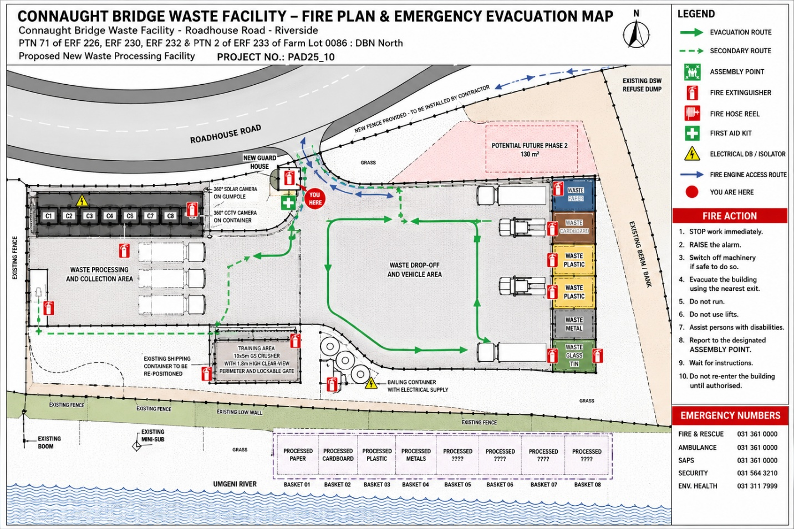The Mavavela Projects Connaught Bridge Waste Processing Facility is located on Roadhouse Road, Riverside, Durban North. The facility comprises a waste processing and collection area, material storage bays, a waste drop-off area, a training area, a guard house, vehicle access routes, parking areas, and secure fencing. The layout has been designed to facilitate safe movement of personnel and vehicles while maintaining access for emergency services

